

**Home Screen ->** Welcomes the user to the Truth! Website.

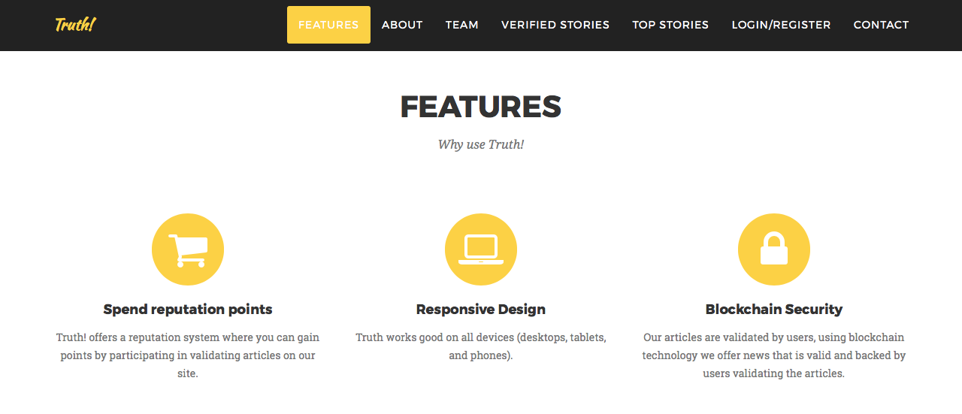

**Features Page ->** Display some of Truth! Interesting features.

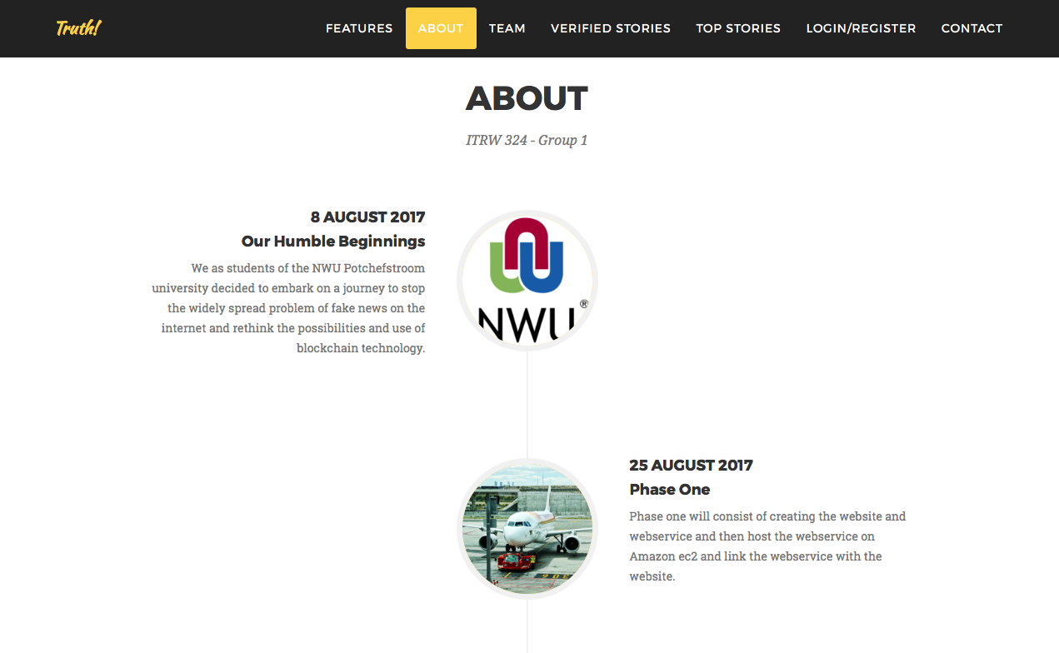

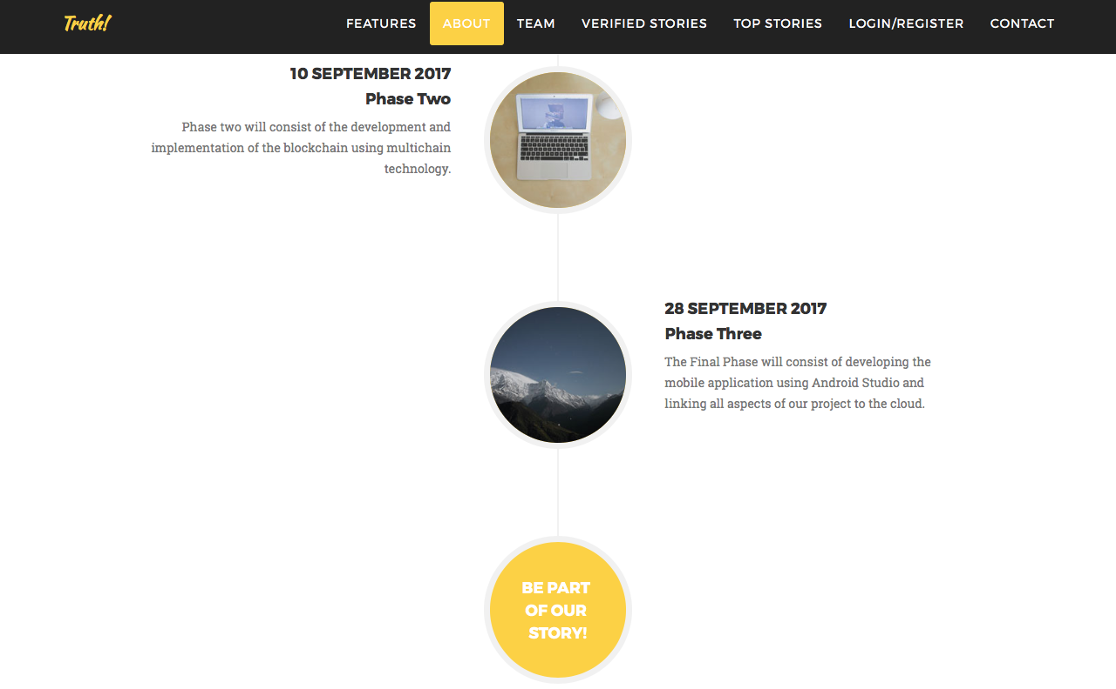

**About Page->** Gives a bit of background information on our group and what we aim to achieve in each of our phases.



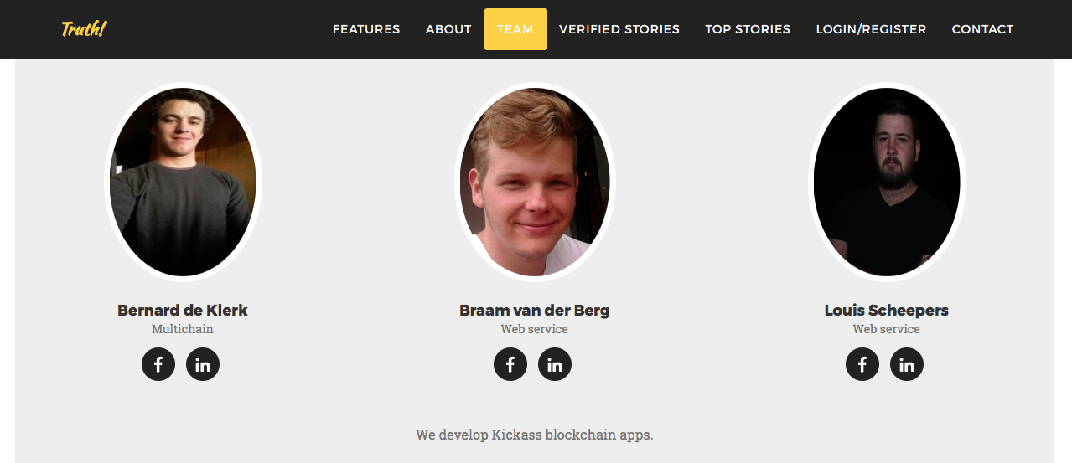

**Team Page ->** Introduce our team of developers and share links to their Facebook and LinkedIn profiles.



**Team Page ->** Showcase some of the technologies used creating the Truth! Platform.

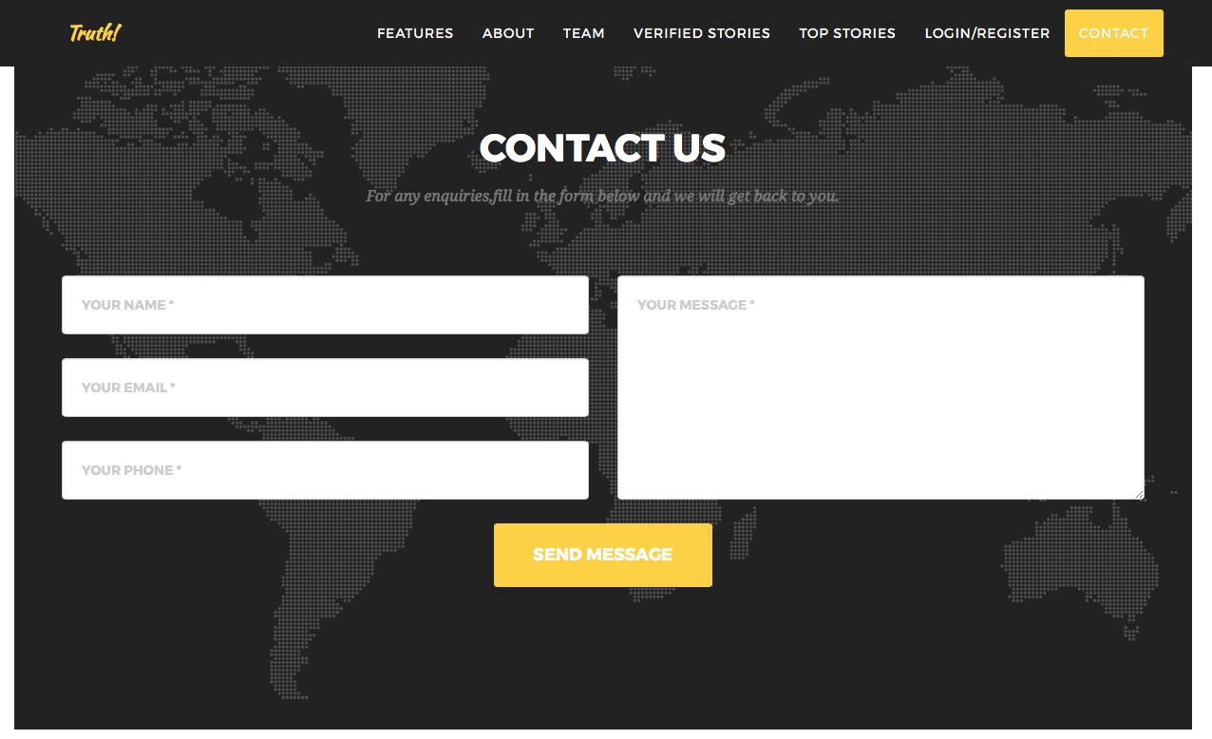

**Contact Page ->** Let’s users get in touch with the Truth! Team.

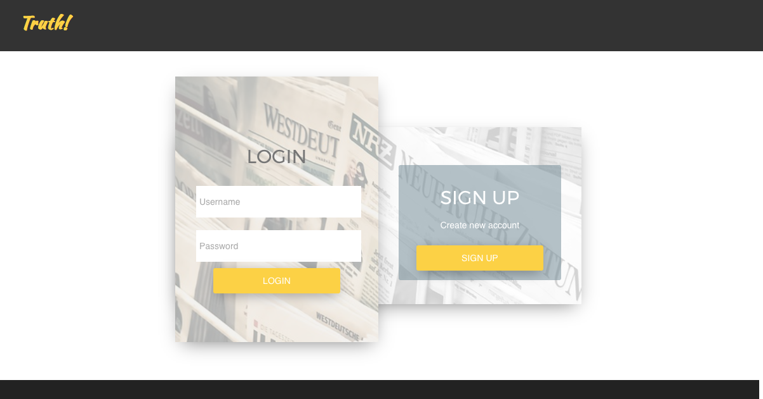

**Login Page ->** The user needs to login first before he/she can start rating articles.

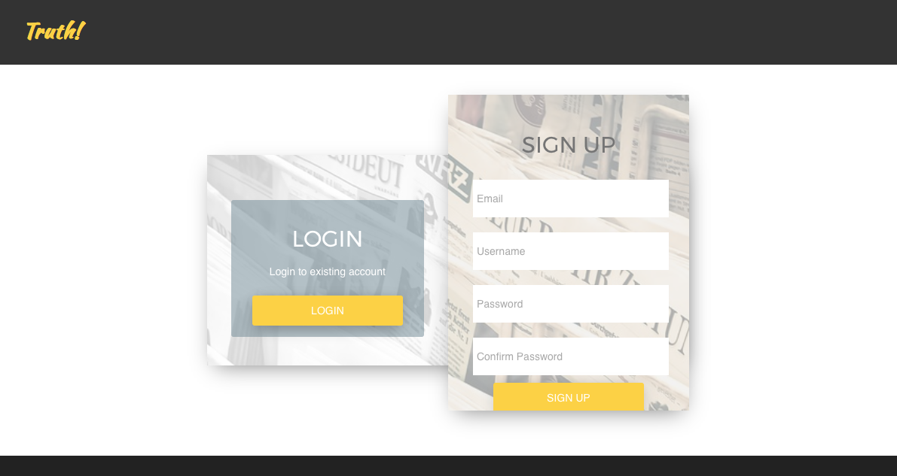

**Register Page ->** If the user aren’t registered yet he/she can sign up to be able to rate articles and earn a reputation via reputation points that can be earned.



**Top Stories Page ->** The top stories page displays all new unverified articles that awaits ratings from user. This page is only a summary of the articles once selected the user will be redirected to the corresponding article page where the user can then rate the article.



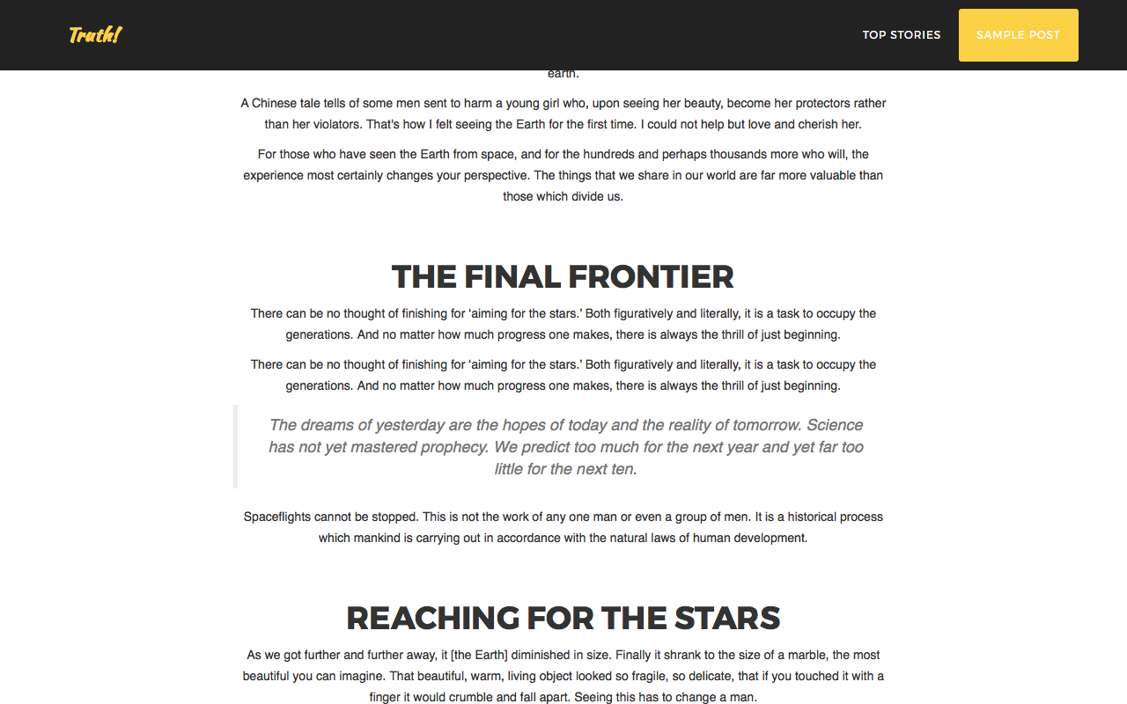

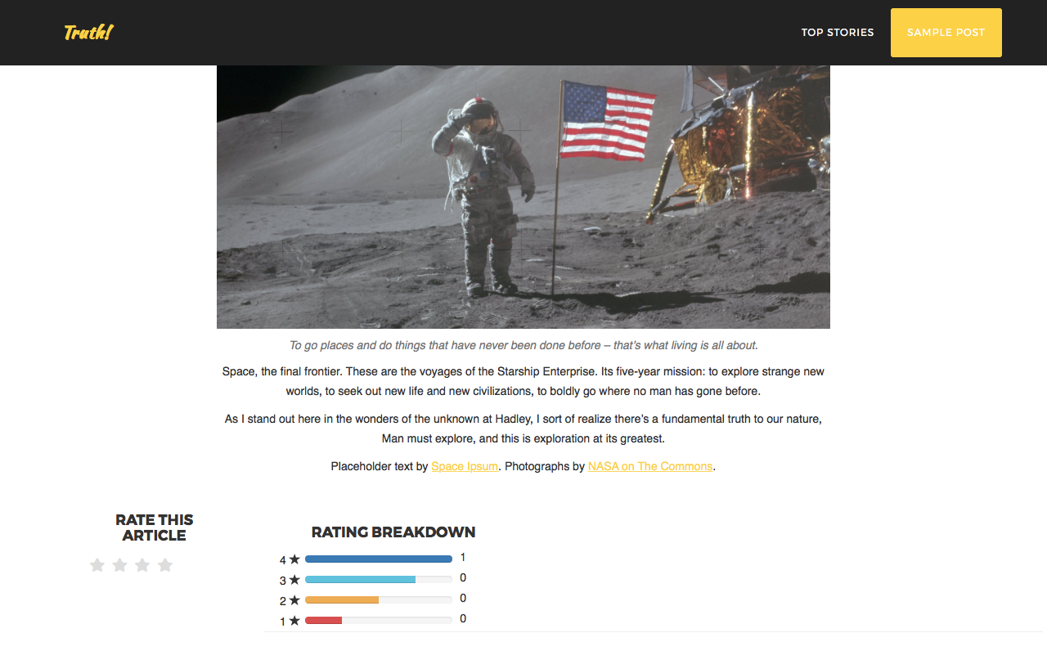

**Article Page ->** The article page display the corresponding article that was selected in the top stories page. Here the user can rate each article once and can also see a breakdown of the ratings the article already have.



**Verified Stories Page ->** All articles that was successfully verified as news that not fake will appear on this page and the user will no longer have the function to rate the article.

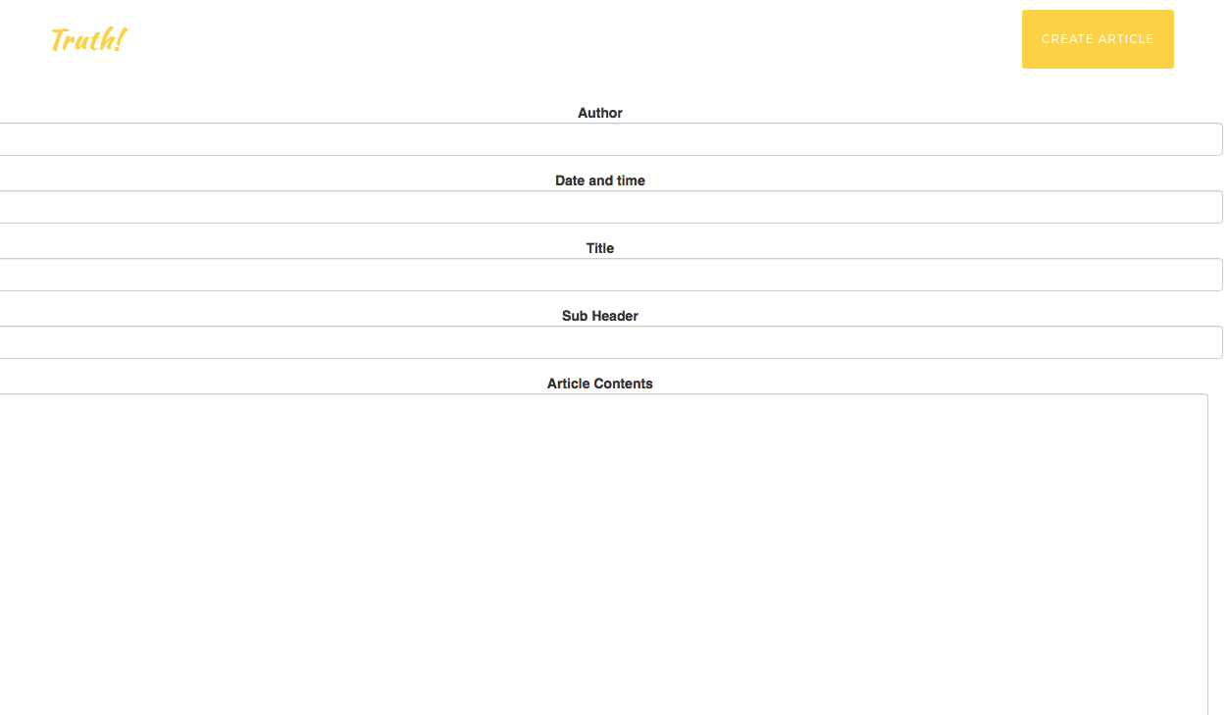  
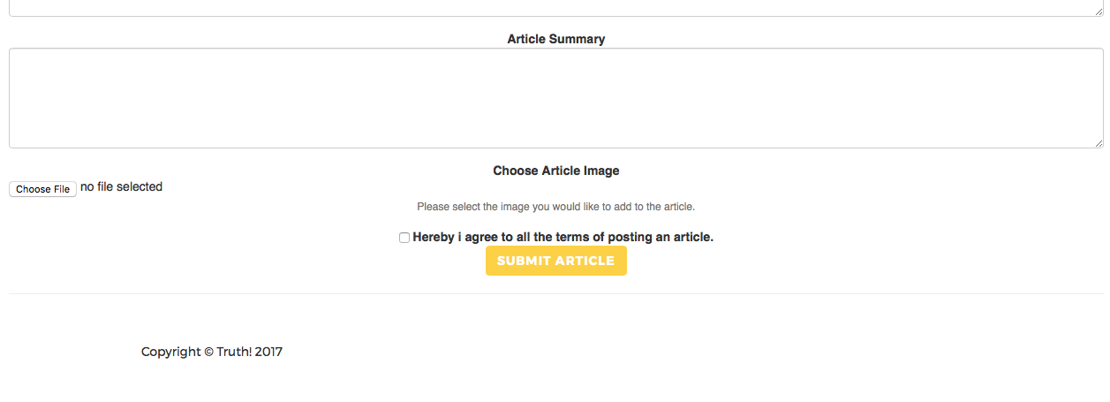

Create Article Page -> Enables admin users to post articles easy and efficiently using our article templates.